


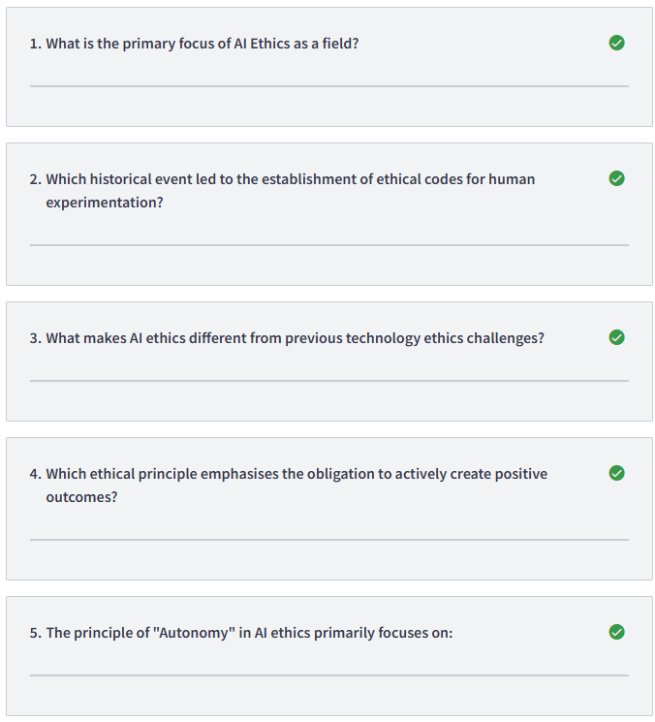
1/ Examining moral principles governing AI design, development, and deployment
2/ The Nuremberg trials after World War II
3/ AI can make millions of decisions per second with potential opacity
4/ Beneficence
5/ Respect for human agency and decision-making
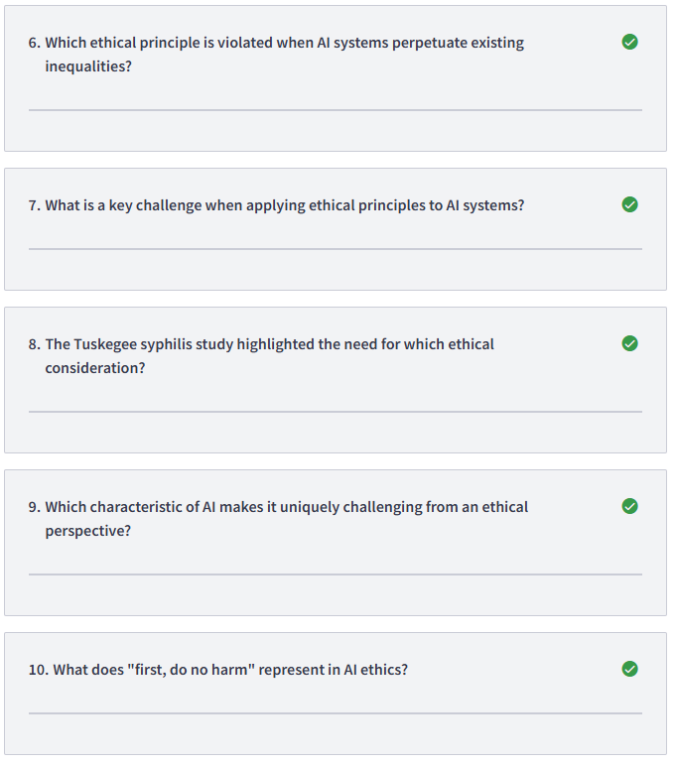6/ Justice
7/ These principles sometimes conflict with each other
8/ Informed consent and ethical oversight
9/ AI learns and adapts in unprogrammed ways
10/ Non-maleficence
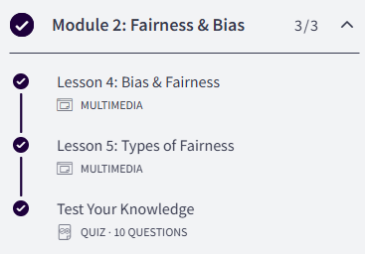
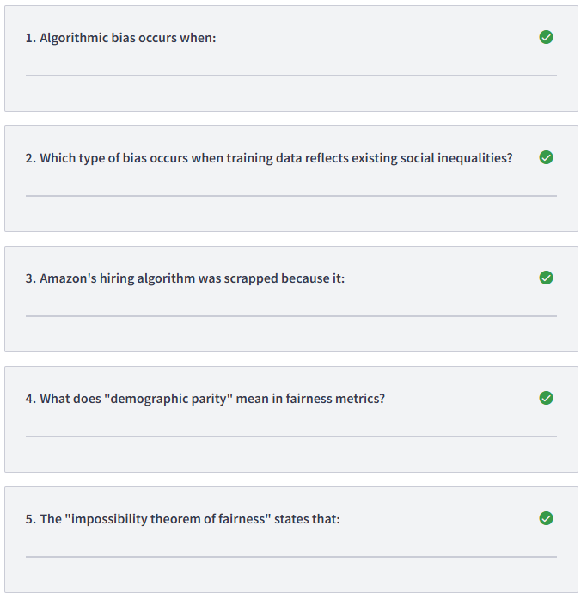
1/ AI systems produce systematically unfair outcomes for certain groups
2/ Historical bias
3/ Discriminated against women due to biased training data
4/ Positive outcomes are proportionally similar across groups
5/ Multiple fairness definitions cannot all be satisfied at once
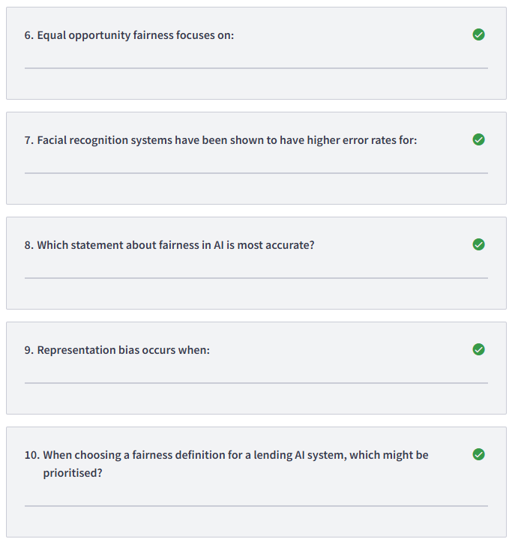
6/ Equal true positive rates across groups
7/ People with darker skin tones
8/ Fairness requires intentional effort and context consideration
9/ Some groups are underrepresented in training data
10/ Predictive parity for reliability
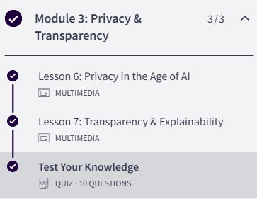
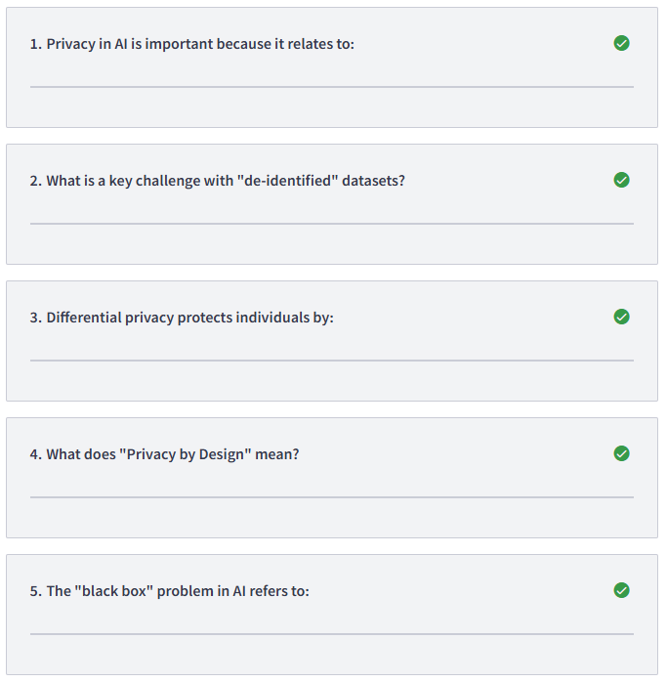
1/ Autonomy, dignity, and freedom from surveillance
2/ They can often be re-identified through cross-referencing
3/ Adding calibrated noise while preserving statistical patterns
4/ Building privacy protections into systems from the start
5/ Difficulty explaining how decisions are made
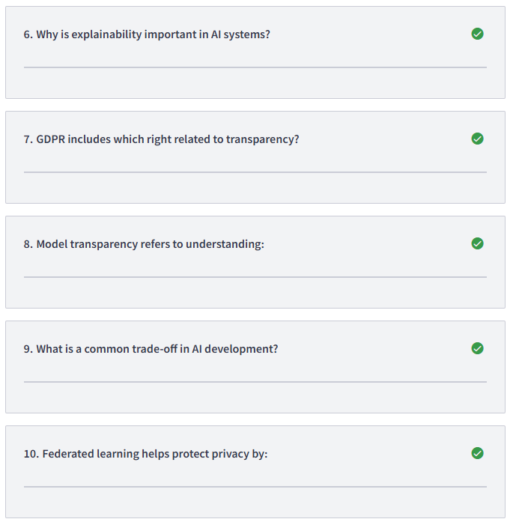
6/ It builds trust and enables oversight
7/ Right to explanation
8/ How the algorithm works in general
9/ Accuracy versus explainability
10/ Training models on distributed data without centralising it

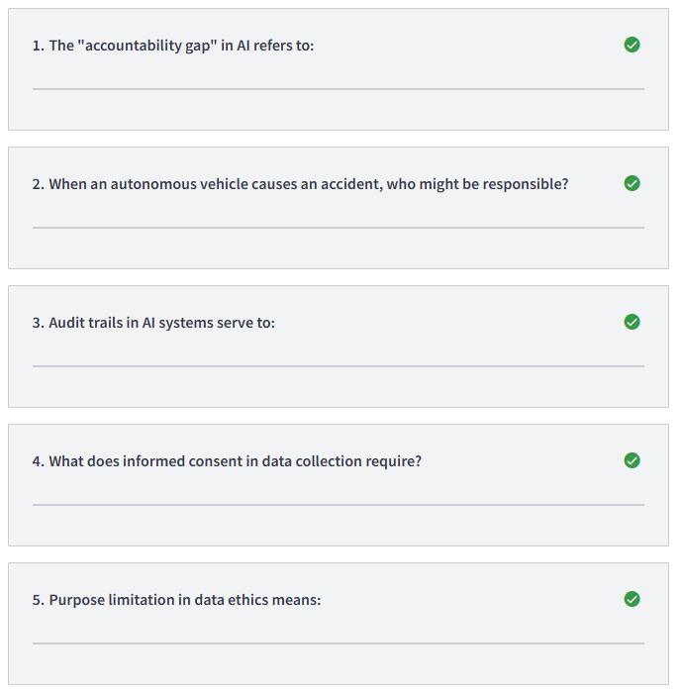
1/ Unclear responsibility when systems cause harm
2/ Multiple parties including manufacturer, developer, and deployer
3/ Record decisions and data for post-hoc review
4/ People knowing what data is collected and how it's used
5/ Data should only be used for its stated collection purpose
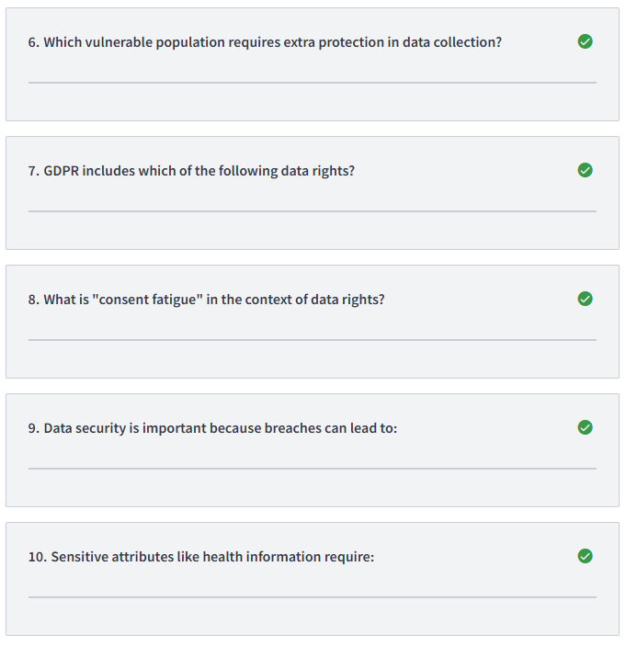
6/ Children and those with cognitive disabilities
7/ Right to erasure (right to be forgotten)
8/ People clicking "accept" without reading due to overload
9/ Identity theft and discrimination
10/ Heightened protections due to potential harm

